Weather Dashboard: Project Summary & Deployment
Data Science project, Zainab

1. Project Summary
The Pakistan Weather Dashboard collects the minimum temperature, maximum temperature, current condition and sunshine status for seven cities of Pakistan (Karachi, Lahore, Islamabad, Peshawar, Quetta, Multan and Faisalabad). The data is stored in Firebase Firestore, analysed and visualised with Python (Seaborn) through a Flask API, and shown in a React website. The app is containerised with Docker.
Data | Open-Meteo API, 7 cities of Pakistan, stored in Firebase Firestore
Backend | Python, Flask, Seaborn, OpenRouter chatbot, hosted on Render (Docker)
Frontend | React.js (Vite), hosted on GitHub Pages
Automation | Docker, Git, GitHub Actions (CI and deploy)

This session added an analytics chatbot, pushed the project to GitHub, set up GitHub Actions, and published the dashboard live.

2. Analytics Chatbot
A chat window on the dashboard answers questions about the weather data, for example which city is hottest, which has the most sunshine, or a comparison of two cities.
- Backend: chat.py adds a /api/chat endpoint. It reads the latest data from Firestore and answers the question.
- Modes: rule-based answers computed from the data, or a natural-language answer from a model through the OpenRouter API when OPENROUTER_API_KEY is set. If the API call fails, it falls back to the rule-based answer.
- Frontend: ChatBot.jsx adds the chat button, message window and suggestion buttons.
- The API key is kept in a .env file that is excluded from Git and from the Docker image.
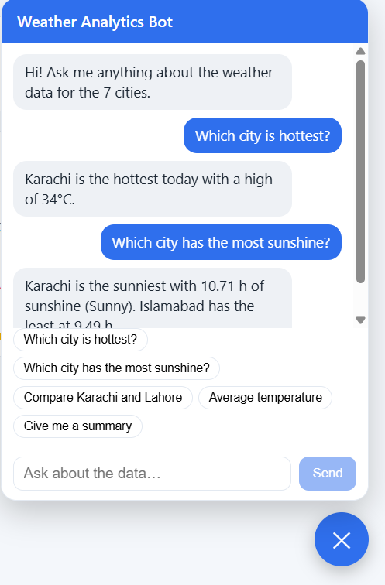
Figure 1: The Weather Analytics Bot answering questions

3. Git Commit and Push
The code was committed and pushed to GitHub. Secrets (.env and the Firebase key) are excluded using .gitignore. When the push was rejected because GitHub had newer commits, they were merged first:
git add .
git commit -m "Add chatbot, Docker setup and daily data refresh"
git pull --rebase origin main
git push

4. GitHub Actions
Two workflows run on every push to the main branch:
- CI: installs the backend dependencies, checks the Python files compile, and builds the React app.
- Deploy to GitHub Pages: builds the React app and publishes it.
The first runs failed for two reasons: the workflow file had no YAML indentation, and the chatbot component was saved as w.jsx while App.jsx imported ChatBot.jsx. After fixing the indentation and renaming the file, all runs passed.
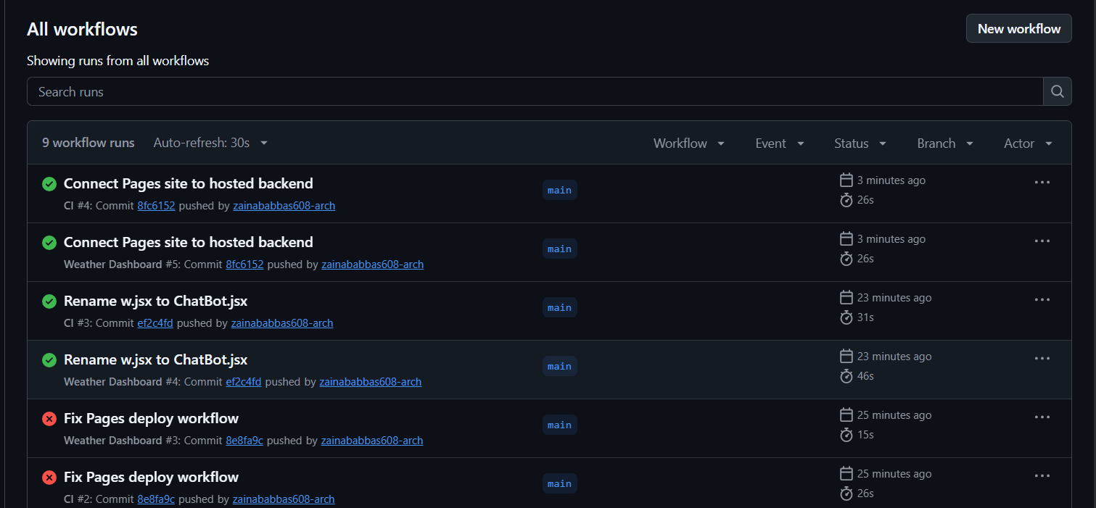
Figure 2: Workflow runs, with earlier failures fixed and later runs passing

5. Live Deployment
GitHub Pages hosts only static files, so the live dashboard needs the Flask backend running on a public server. The deployment has two parts.

5.1 Backend on Render
- A Render web service was created from the GitHub repository using backend/Dockerfile.
- The Firebase key is stored as a Render secret file, and settings such as FIREBASE_KEY_PATH and the OpenRouter key are environment variables, so no secret is stored in GitHub.
- The service answers at /api/health, /api/cities and /api/charts.
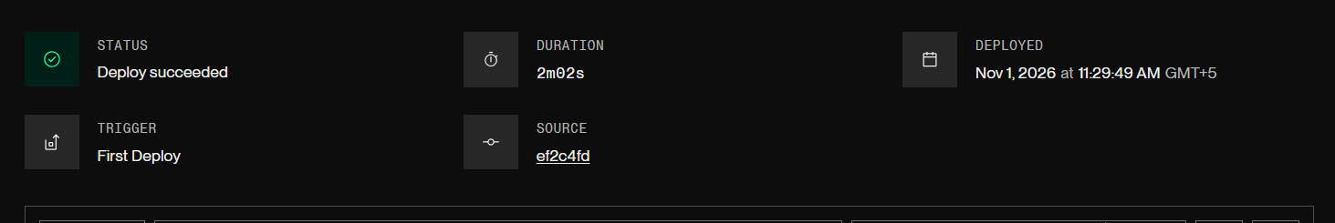
Figure 3: Render deploy succeeded

5.2 Frontend on GitHub Pages
- frontend/.env.production sets VITE_API_BASE to the Render backend address, so the site calls the live API.
- In Settings → Pages, the source was set to GitHub Actions. The Deploy workflow publishes the site on each push.
Figure 4: GitHub Pages reports the site is live
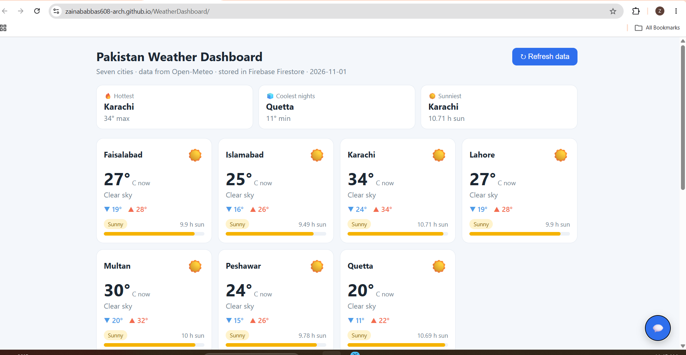
Figure 5: The live dashboard at zainababbas608-arch.github.io/WeatherDashboard

6. Result
The dashboard is live online and shows current weather for the seven cities, the Seaborn charts, and a working analytics chatbot. The data refreshes automatically once per day on the first visit. Pushing to GitHub rebuilds and republishes the frontend. The backend runs as a Docker container on Render.

